

Smart Walk Stick

Group Members:

1. Hamza Shahid. (1449380)
2. Shaheer Ahmed. (1422355)
3. Ebad Ali. (1491151)
4. Sidrat-ul-Muntaha. (1405363)
5. Ritaba Hasan. (1429913)
6. Bisma Gul. (1425674)

**Table of Contents:**

**Abstract1**

**Problem Statement2**

**Proposed Solution3**

**Components4**

* Sensor1
* Raspberry Pi2
* Audio Sensor3
* Water Level Sensor4
* Battery5
* Buzzer6
* Smartphone7
* PIR Sensor8
* Jumper Wires9
* Camera10

**Design7**

**Architecture8**

**Circuit Diagram10**

* LED Circuit10
* PIR Circuit13
* Water Level Circuit14
* Audio Circuit16
* Camera Module Circuit18

**Functional Requirement20**

**Non-Functional Requirement21**

**Software22**

**Comclusion22**

# ABSTRACTS

Mobility and freedom are substantially impacted by visual impairment. We suggest creating a cutting-edge "Smart Stick" that incorporates cutting-edge technologies to improve the lives of blind people in order to address this difficulty. In a convenient and portable packaging, this assistive technology seeks to offer real-time navigation, obstacle detection, environmental awareness, and communication capabilities.

# PROBLEM STATEMENT

The hardest thing for someone who is blind or visually impaired to do is engage with and feel their surroundings. For these people, physical mobility can be difficult since it can be difficult for them to discriminate between different types of impediments that may occur in their path. This makes it difficult for them to travel from one location to another.

An obstruction in the user's way can be photographed and then sent as an alarm through the user's smartphone, where the user will hear the message.

A blurry scene may be captured on camera while the program is trying to take pictures due to excessive lighting or the humidity of the environment.

* + **Mobility and Navigation:** Moving about independently might be difficult for blind people. Using public transportation, finding your way through strange environments, and dodging obstacles might be challenging.
  + **Access to Information:** Reading printed materials, viewing visual content, and understanding information presented in graphical form can be difficult for blind persons. This includes reading books, newspapers, websites, and other visual media.
  + **Education:** It may be challenging for blind students to access educational resources like textbooks and visual aids. It is frequently necessary to use specialized materials, equipment, and training to ensure that children obtain a good education. numerous career options for blind persons.

# PROPOSED SOLUTION

Visual impairment significantly impacts an individuality, independence and mobility. To address this challenge, we propose the development of a cutting-edge ,Smart Stick that integrates advanced technologies to enhance the lives of blind individuals. This assistive device aims to provide real-time navigation, obstacle detection, environmental information, and communication capabilities, all in a user-friendly and portable package.

# COMPONENTS AND MODEL

Smart motion sensor alarm, WiFi Movement detector with Remote PIR

Security system, compatible iOS or Android devices, or PIR Sensors and

Camera are used

SENSORS:

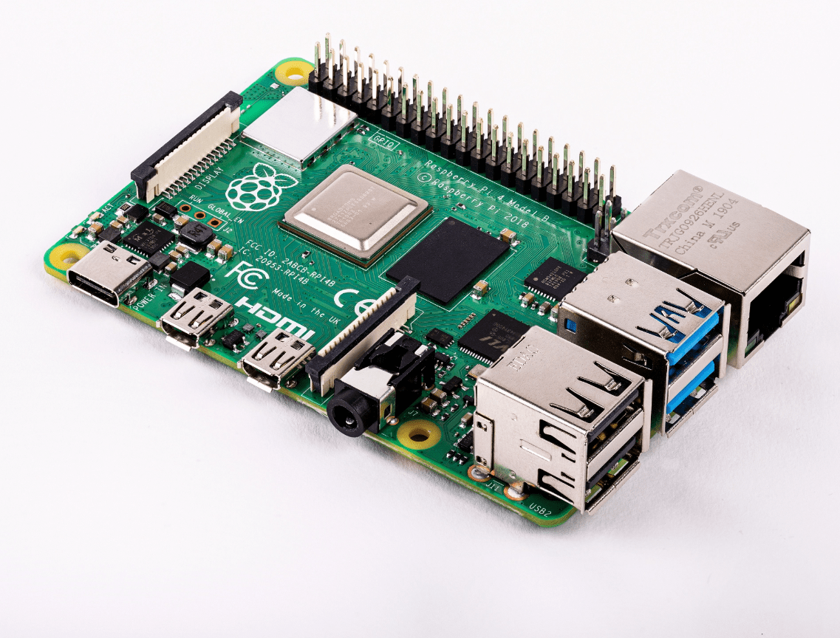

## RASPBERRY PI

As soon as the power supply is turned on, the system starts to operate. The obstruction is then detected using the ultrasonic sensor, which also measures the distance between the obstacle and the object. Navigation is provided using a GPS module. The Raspberry Pi device will be used to process the distance and the navigation when an obstruction is detected.

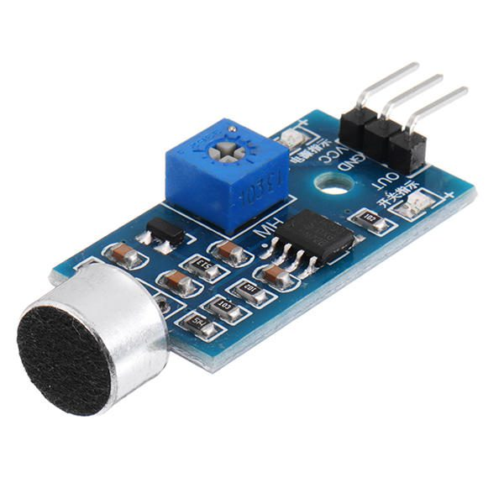

## AUDIO SENSOR

The smart stick for the blind is a navigational aid for those who are blind or visually impaired that helps them avoid obstacles and find their way. To gauge the depth below or the distance between obstructions, it uses two HC SR 04 ultrasonic sensors.

## https://airforshare.com/files/EqfUgg.jpgWATER LEVEL SENSOR

If water is detected in front of the blind user, the water sensor module will measure the water level and relay that information to the Arduino Uno microcontroller, which will utilize the information to calculate whether or not the user needs to go in a particular direction.

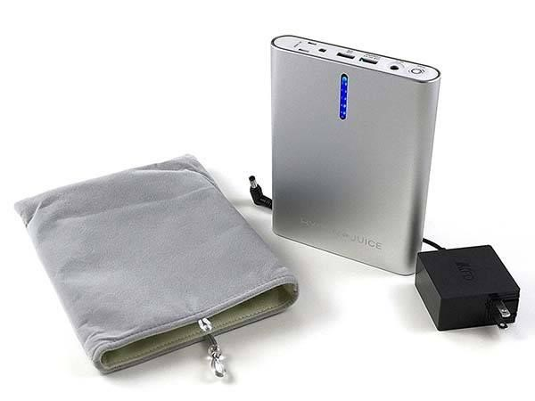

## BATTERY

In many electrical devices, like smart sticks,

batteries are crucial parts. They supply the required

electricity to run the devices electronic circuits and

parts.

## BUZZER

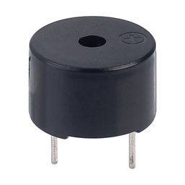 The stick has an ultrasonic sound sensor built into it so that the buzzer only activates when the system detects an obstruction. so that a blind person may determine which side is free from obstructions. And different beep sound effects will be created on different sides.

## SMARTPHONE

Wireless technologies like Bluetooth are frequently used to connect a smartphone to a smart walking stick. With the help of this link, the smart walking

stick may talk to a smartphone and perhaps provide

functions like tracking, alarms, and remote control.

## PIR SENSOR

A PIR sensor is similar to a unique device that can detect movement nearby. It accomplishes this by sensing the heat emitted by people or animals.

It instructs other items, like lights or alarms, to turn on when it detects this change in temperature. As a result, it facilitates automated operation whenever a person passes by..

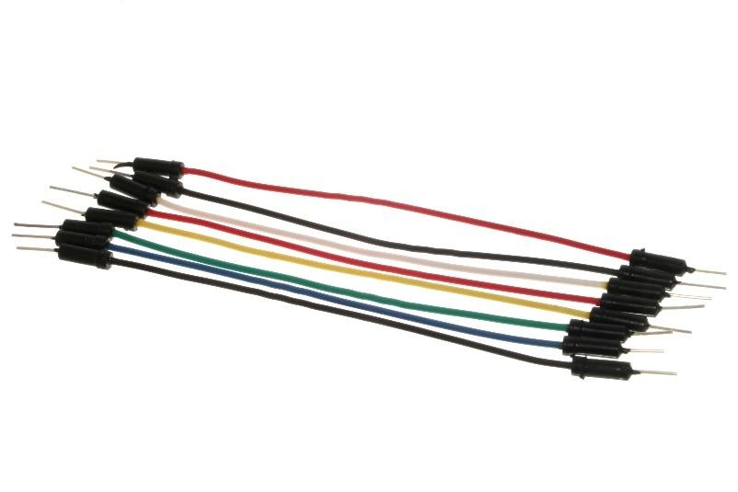

## JUMPER WIRES

Smart walk sticks can be more beneficial with the use of a jumper wire, which is widely used in electrical and electronic circuits. A smart walk stick is a device designed to make it easier for people to navigate their surroundings when they have vision or mobility challenges.

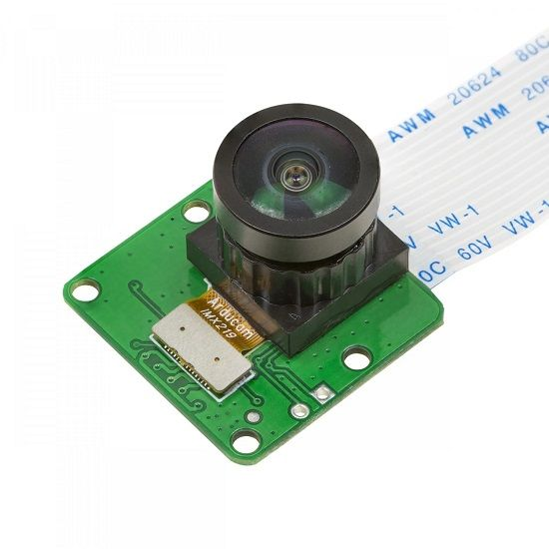

## CAMERA

A smart walking stick with a camera is usually equipped with technology to enhance the user experience and walking safety.

­­

DESIGN MODEL:

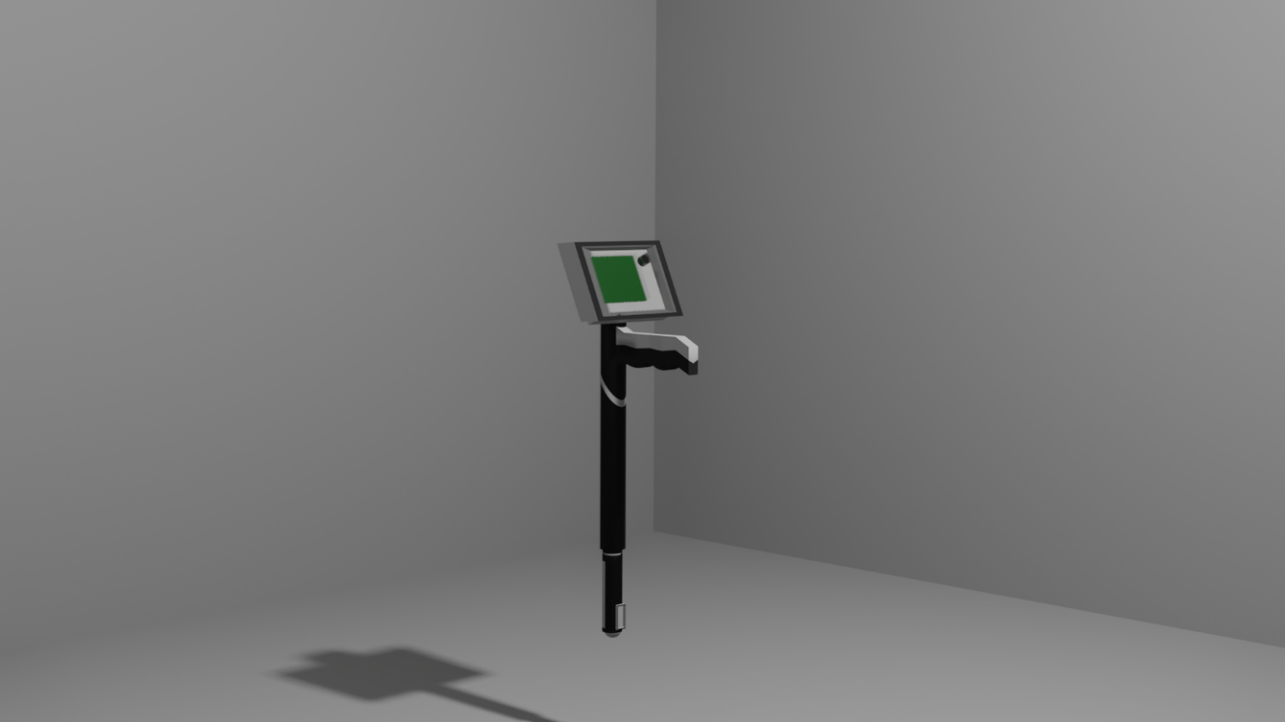

ARCHITECTURE:

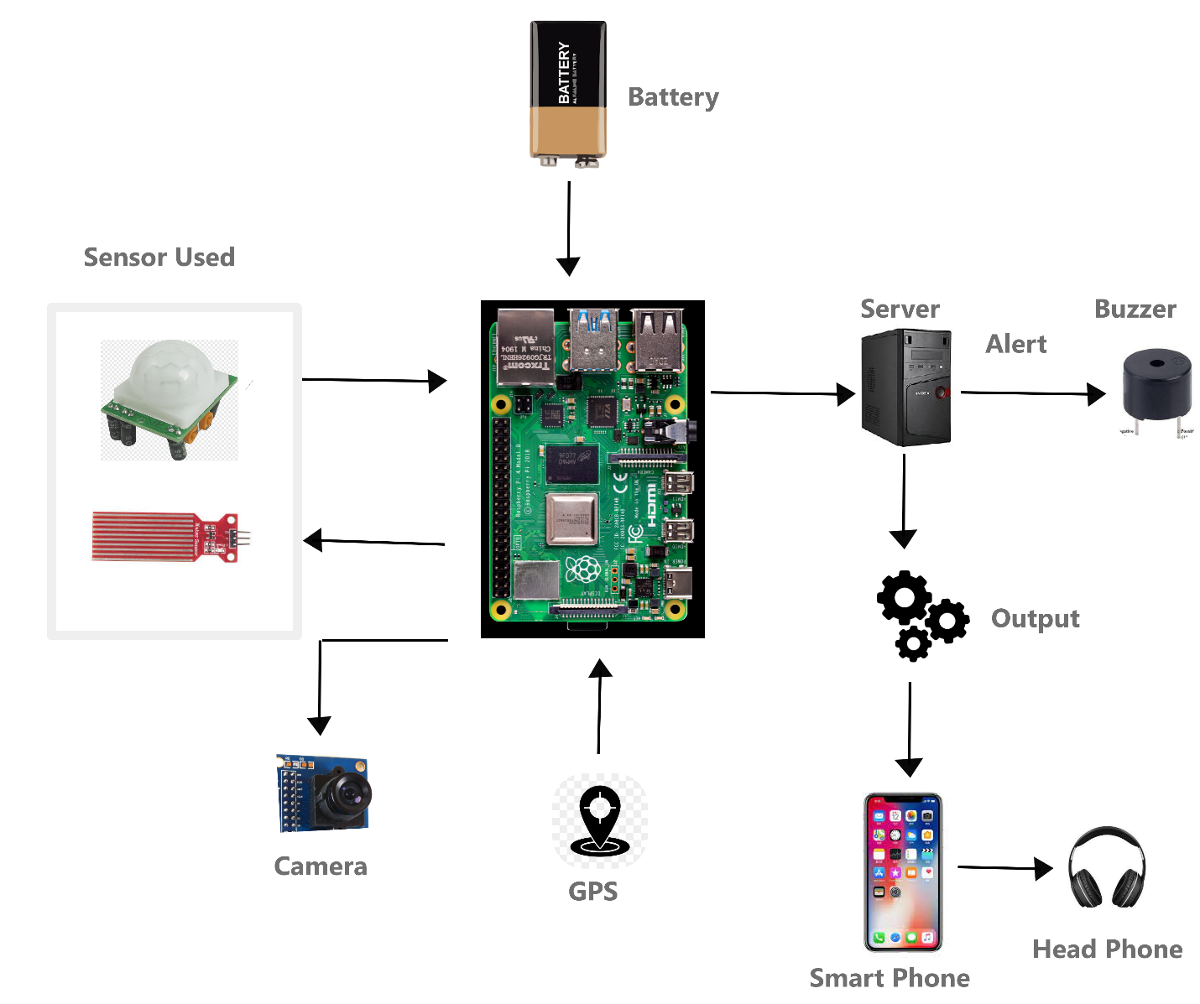

## Discription:

A highly advanced tool called a "smart blind stick" is intended to help visually impaired people navigate their surroundings effectively and safely. A smart blind stick's architecture typically consists of a mix of hardware parts, sensors, data processing units, and user interface components.

The architecture is described in general as follows:

**1.Hardware elements**

* **Handle:** The user's main point of contact with the blind stick is the handle. It might have touch-sensitive or button sections for interaction and control.
* **Sensors:** The blind stick contains a number of sensors that collect information about the surrounding area. These sensors may be gyroscopes, accelerometers, GPS units, infrared sensors, ultrasonic sensors, and others.
* **MicroProcessor:** A microcontroller or processor unit is the brain of the blind stick, responsible for processing sensor data and controlling various functions of the device.
* **Mechanism for Haptic Feedback:** The blind stick may have a mechanism that gives the user haptic feedback, such as vibrating or producing varied patterns of vibration to alert them to changes or impediments in the surroundings.
* **Audio Output:** The user receives auditory information and alarms from an audio output component, such as a speaker or earphone.
* **Connectivity:** The blind stick connect with Bluetooth or Wi-Fi wireless connectivity features to link to other devices or the user's smartphone.

**2.Sensing devices and data gathering**

* Ultrasonic sensors: These devices produce ultrasonic waves and track how long it takes for the waves to return to normal after colliding with a surface. This aids in detecting obstacles in the user's path.
* Using infrared sensors, which emit and pick up on reflected infrared light, it is possible to identify nearby obstructions.
* Gyroscopes and Accelerometers: By tracking the orientation and motion of the blind stick and reporting on the user's gestures and the stick's position, these sensors assist in tracking the stick's orientation and movement.
* GPS Module: If present, the GPS module can offer location data that can be utilized for navigation and to give the user context regarding their surroundings.

**3.Decision-Making and Data Processing:**

* To make wise decisions, the microcontroller or processor processes input from numerous sensors. To find impediments, changes in the terrain, and other environmental conditions, it analyzes the sensor data.
* The blind stick helps the user avoid obstacles and navigate safely by implementing algorithms for obstacle recognition, path planning, and localization.

**4.User Interface and Interaction:**

* The blind stick is operated and interacted with by the user using buttons, switches, or touch-sensitive regions on the handle.
* Auditory warnings: The blind stick also give the user auditory warnings, such as voice cues or sound signals, to warn them of obstacles, crossroads, or other environmental changes.
* Haptic Feedback: Haptic signals, such as vibrations, can alert the user of the nature and vicinity of obstacles.

**5.Energy Source:**

* The sensors, processor, and other parts of the blind stick are often supplied by a rechargeable battery, which supplies the electricity they need to function.

**6.The incorporation of mobile devices**

* wirelessly connected smart blind sticks can communicate with smartphones or other gadgets. By adding more navigational aids, mapping, and accessibility features, this integration can improve the device's functionality

Overall, the design of a smart blind stick strives to produce a comprehensive and user-friendly assistive tool that enables people with vision impairments to safely and independently navigate their surroundings.

CIRCUIT DIAGRAM:

## LED CIRCUIT :

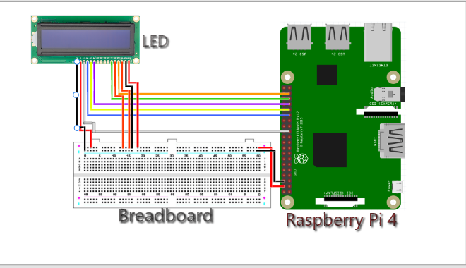

## **Discription:**

A Raspberry Pi 4 is connected to an LCD (Liquid Crystal Display) using a number of processes and parts. A general explanation of connection of an LCD to a Raspberry Pi 4 is provided below:

1. **Choosing an LCD:**

Decide on an LCD that is appropriate for our project and is compatible with the Raspberry Pi 4. Ensure that the LCD includes all required connections and connectors.

1. **Pin Compatibility:**

The Raspberry Pi and the majority of LCDs also interact with each other via a variety of interface protocols, including HDMI, DSI (Display Serial Interface), and SPI (Serial Peripheral Interface). Make sure the LCD's interface is appropriate for the Raspberry Pi 4's ports by checking.

**3. Physical Relationship:**

* For HDMI, we joined the HDMI output of the LCD and the HDMI input of the Raspberry Pi 4 using an HDMI cable.
* To use DSI, attach the DSI ribbon cable from the LCD's DSI connector to the Raspberry Pi 4's DSI port. Ensure that the pins are correctly aligned.
* Then Connected the LCD's SPI pins, which are typically SCLK, MISO, MOSI, and CS/CE, to the corresponding GPIO pins on the for SPI.Pi 4 Raspberry. Additionally, you might need to connect the ground (GND) and power (VCC) pins.

**4. Power Source:**

* According to the LCD's power requirements, supply electricity. This may entail connecting the Raspberry Pi's power supply or an external power source to the power pins (VCC and GND).

**5. Installing drivers:**

* For HDMI, most HDMI monitors should function right out of the box without the need for additional drivers.
* For DSI or SPI: The Raspberry Pi may need to have particular drivers installed in order to support some LCDs. Install the required drivers or set up the Raspberry Pi so that it can detect the display by adhering to the manufacturer's instructions.

**6.Configuration**:

* It need to change the configuration files for the Raspberry Pi depending on the LCD and interface used. For instance, you might need to enable the DSI interface in the config.txt file for a DSI display.

**7.Calibration and testing**

* Turn on the Raspberry Pi once everything is set up and linked. You ought to be able to view the display output on the LCD screen if the LCD is correctly connected and recognized.
* If necessary, you might need to calibrate the touchscreen using the right tools or software.

**8.Application Integration:**

* We can create or change software to interact with the LCD depending on your project. This can entail making use of libraries, APIs, or frameworks to manage user input and display content.

Keep in mind to refer to the documentation and instructions offered by the LCD's maker for any particular instructions pertinent to your model. We also use caution while handling hardware components, and turn the Raspberry Pi off before connecting or adjusting anything.

## 2 PIR CIRCUIT :

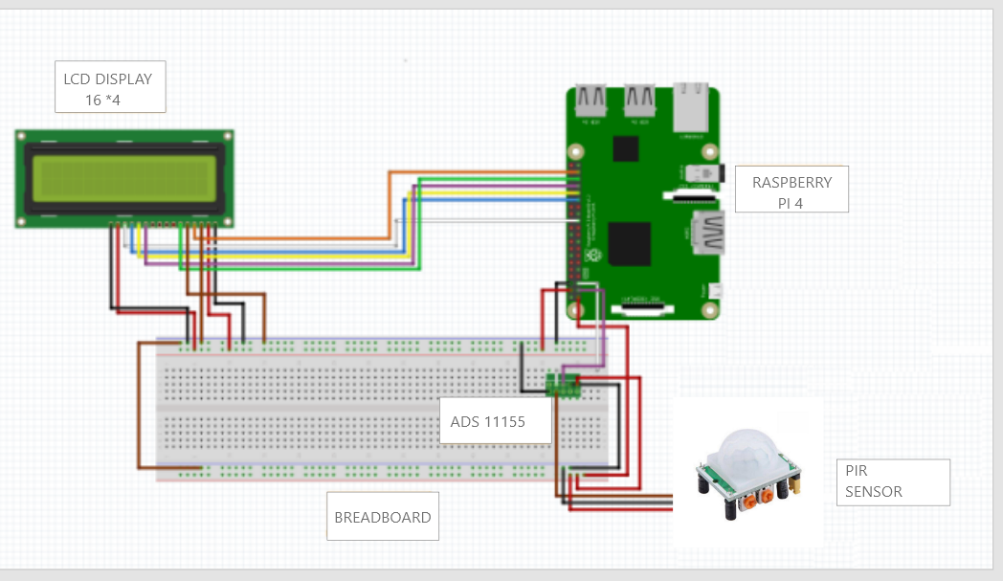­­­­

## Discription:

On the basis of variations in infrared light within its range of vision, passive infrared (PIR) sensors are frequently employed to detect motion. Applications like automation, lighting control, and security systems frequently employ it. There are a few stages, including wiring and programming, involved in connecting a PIR sensor to a Raspberry Pi 4. A general explanation of how to do it is provided below:

**Wiring the PIR Sensor to Raspberry Pi 4:**

**1.Power Source:** PIR sensors commonly run on 3.3V to 5V power supplies. On the Raspberry Pi GPIO header, the 5V pin (Pin 2) and Ground (Pin 6) can be used for power.

**2.Output Pin:** When motion is detected, the PIR sensor's output pin will go HIGH. This pin is connected to a Raspberry Pi GPIO pin. Select the GPIO pin you want to utilize, such as GPIO17 on Pin 11.

**3.Ground Connection:** We joined Ground (GND) pin on the Raspberry Pi, such as Pin 9, with the Ground (GND) pin of the PIR sensor.

**4.Voltage Connection:** Attached the PIR sensor's Voltage (VCC) pin to a Raspberry Pi 3.3V or 5V pin (for example, Pin 2 for 5V).

## WATER LEVEL CIRCUIT :

## 

## Discription:

**1.Interface for Connection:**

We use the proper interface to connect the sensor to the Raspberry Pi. I2C, SPI, UART, and GPIO pins are examples of typical interfaces. We use the raspi-config utility to enable the Raspberry Pi's corresponding interfaces for I2C or SPI sensors.

**2.GPIO Pins:**

We also connect the sensor's output pins to the proper GPIO pins on the Raspberry Pi if our sensor uses GPIO pins for digital or analog communication. Make that the pins are configured correctly in our code and that we have the correct pin numbers.

**3.I2C or SPI:**

Our sensor uses I2C or SPI, attached the corresponding pins from the sensor (SDA/SCL for I2C, MOSI/MISO/SCLK for SPI) to the corresponding pins on the Raspberry Pi. The pin configurations and numbers are proper once more.

**4.Coding and Testing:**

We wrote code on the Raspberry Pi to communicate with the sensor using the appropriate communication protocol (GPIO, I2C, SPI, etc.). Libraries are often available for popular sensors to simplify the process. Test the communication and sensor readings to ensure everything is working as expected.

**5.Software Configuration:**

Depending on the sensor and communication method, you might need to install additional software libraries or drivers on the Raspberry Pi to support the sensor's communication protocol.

## AUDIO CIRCUIT :

## Discription:

**1.Choosing an Audio Sensor:**

We picked a microphone or audio sensor module that works with the Raspberry Pi 4. There are several choices, including USB microphones, I2S-based microphones, analog or digital microphones. Make that the Raspberry Pi 4's USB ports or GPIO pins can accommodate the sensor's interface.

1. **Setup of Software:**

Installed an appropriate operating system, such as Raspbian (formerly named Raspberry Pi OS), or any other compatible distribution, on your Raspberry Pi 4.

1. **Audio Libraries:**

In order to record and edit audio, we use audio libraries. Several well-liked libraries for this purpose are:

The Raspberry Pi and other Linux-based systems are supported by ALSA (Advanced Linux Sound Architecture). For handling audio input and output, it provides tools and APIs.

* With PyAudio, you worked with audio input and output quickly and easily. PyAudio is a Python library that offers Python bindings for the PortAudio library.
* Digital audio sensor data also handled with the aid of WiringPi, a library for dealing with GPIO pins.

Once we obtain the audio data from the sensor, we can process it in accordance with the requirements of your application. Any audio-related activity, such as processing the audio stream, identifying sound events, applying filters, or performing speech recognition, may be included.

## CAMERA MODULE CIRCUIT :

## Discription:

1.**Mounting the camera:**

Placeed the Raspberry Pi Camera Module on the walking stick in a place that allows for a clear view of the surrounding area.

**2. Processing of images:**

* In order to download pictures or video frames from the camera, we use Python and the PiCamera module.
* Implement methods for image processing to find obstructions, signs, or other important aspects. we might employ computer vision strategies like optical flow, edge detection, or object detection.

**3.Detecting obstructions**

* It Analyze the photos that were recorded to find any hazards or obstructions in the user's way.
* It Utilize algorithms to calculate the distances between detected barriers and the user so they can maneuver around them.

**4.Interface for users:**

* It Create a user interface with LEDs or a display to give the user visual feedback or instructions.
* It Create input methods such as buttons or other input devices so the user may interact with the gadget.

**5.Connectivity:**

We use wireless connectivity (such Wi-Fi or Bluetooth) to let a computer or a smartphone remotely control or configure the smart walking stick.

**6.Iteration and testing**

* To optimize the performance of the smart walking stick, test it in various settings and conditions.
* It Obtain user input and make any necessary modifications to enhance functionality and usability.

Keep in mind that developing a smart walking stick requires both hardware and software. For the enclosure design, we need some familiarity with programming, electronics, and potentially 3D modeling. The particular capabilities and features of your smart walking stick will also rely on your objectives and the technology you decide to use.

Always seek out thorough instructions and support from official documentation, online tutorials, and community forums while we work on our project.

FUNCTIONAL REQUIREMENT:

Following are the functional requirements of the system:

**1. Motion Detection:**

The system perform motion detection. It can

use Passive Infrared (PIR) sensors and a method to run itself and detect

the environmental parameters. This sensor are connected to a

Raspberry Pi device.

**2. Water level Sensor:**

This will produce a message in the Raspberry Pi if

the Walking Stick comes across water and accordingly the audio will be

reflected to the user.

**3. Image Capture:**

The system captured images of all objects appearing

in front of the user and messages will be generated via Text-To-Speech

(TTS) and the user will be alerted via buzzer/alarm.

**4. GPS:**

Smartphone will receive the signals (distance) from the

satellites and output depending on the directions will be

updated on the mobile device.

**5. Data Processing:**

The system must process all data collected by the

sensors and alert the user via a buzzer/alarm through the user’s mobile

phone regarding how many steps to be taken or what obstacle is present

in front of the user.

**6. Audio Message:**

A message will be transmitted using user’s Mobile device

where the output will be an Audio voice which will be

heard via Earphones that the user will be accompanied

with.

**Messages that will be shared as Audio feedback:**

* ‘2 meters away, there is wall’.
* ‘After five steps, there is a staircase that will be encountered’.
* ‘Walk Forward, Turn Left, Stop, Enter, Exit, Hold the left side’.

Over and above this, the system has following functionalities:

* The system has allowed to observe the indoor and outdoor environmental parameters.
* It also convey the audio message to the user

which will be generated via a buzzer.

NON-FUNCTIONAL REQUIREMENT:

There are several non-functional requirements that fulfilled by the

system.

The system involved the following:

**1.Portability:**

The mobile device is fully compatible.

**2.Availability:**

Internet connection will be available 24/7 for tracking GPS

location and transmitting the audio output to the end-user.

**3.Delivery:**

The audio output language also localized to the preference of the

user.

**4.Space Efficiency:**

The system measure the area between the user and

obstacle and generate an audio message for precautionary factors.

**5.Performance Efficiency:**

The system also perform in a proper time constraint

that reflects the walking speed, obstacles and motion in the environment.

SOFTWARE:

Technologies used:

1. Python 3.x or higher

2. Raspbian OS

3. IoT/Python related libraries for image capturing and sensors

# CONCLUSION:

A significant advancement in assistive technology is the smart walking stick, which aims to increase the freedom and mobility of people with various degrees of mobility difficulties. Thanks to the incorporation of multiple sensors, connectivity features, and cutting-edge algorithms, the smart walking stick offers a number of benefits above and beyond those offered by traditional walking aids.The smart walking stick has the potential to completely improve the lives of those with mobility challenges because of its real-time input, increased safety, navigational assistance, and greater connectivity. We may expect substantial developments in this field as technology advances, leading to ever more sophisticated and practical smart walking sticks that are specifically designed to meet the needs of those with mobility challenges.